Linux Fundamental

**Q2. L2 - As a Linux root user Create Files/Directory in the same Instance and change the ownership to a new user**

**Ans : First of create EC2 Ubuntu Instance**

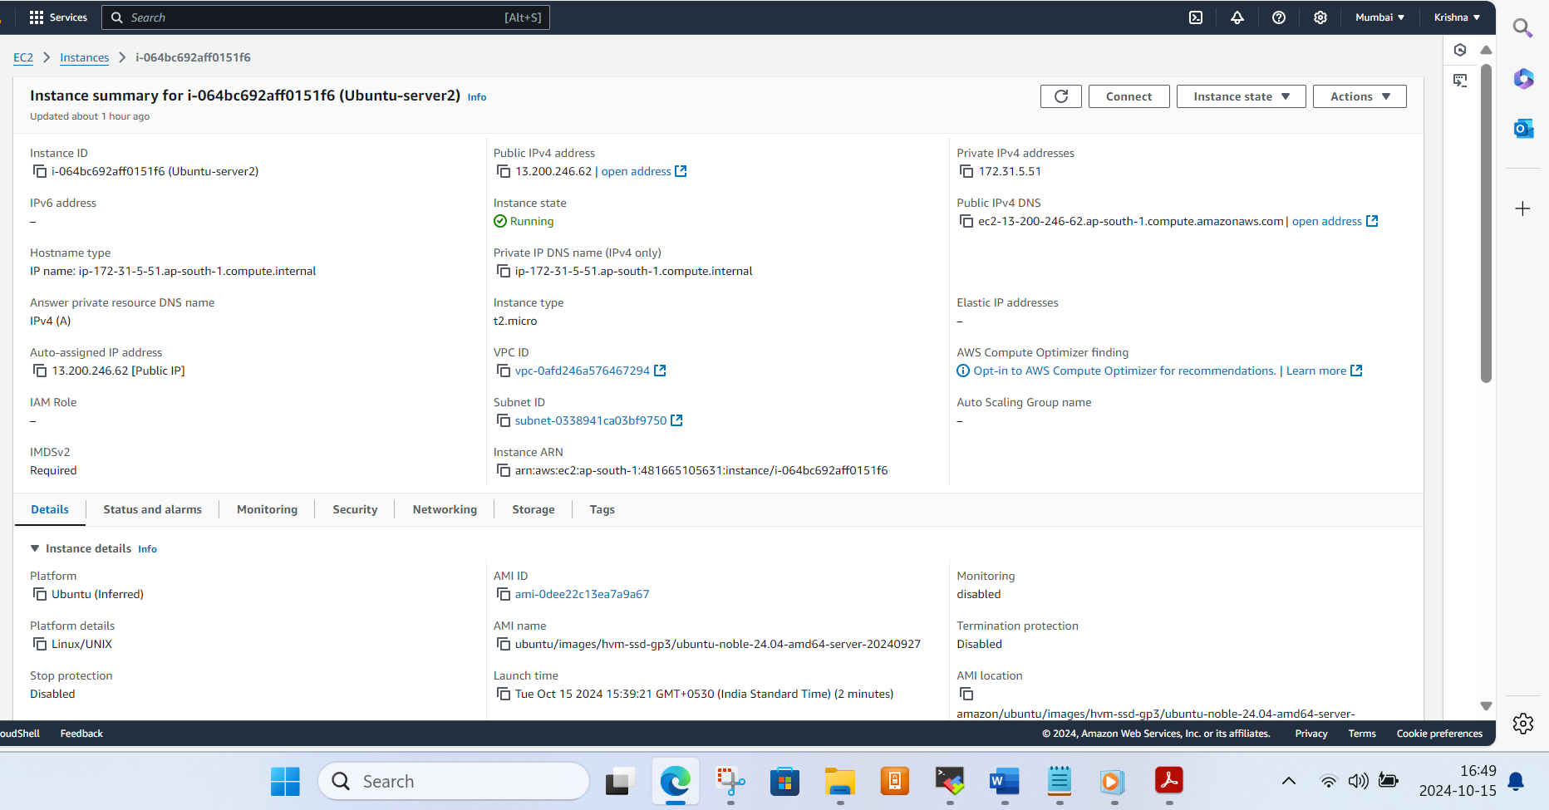

**Login trough mobaxterm**

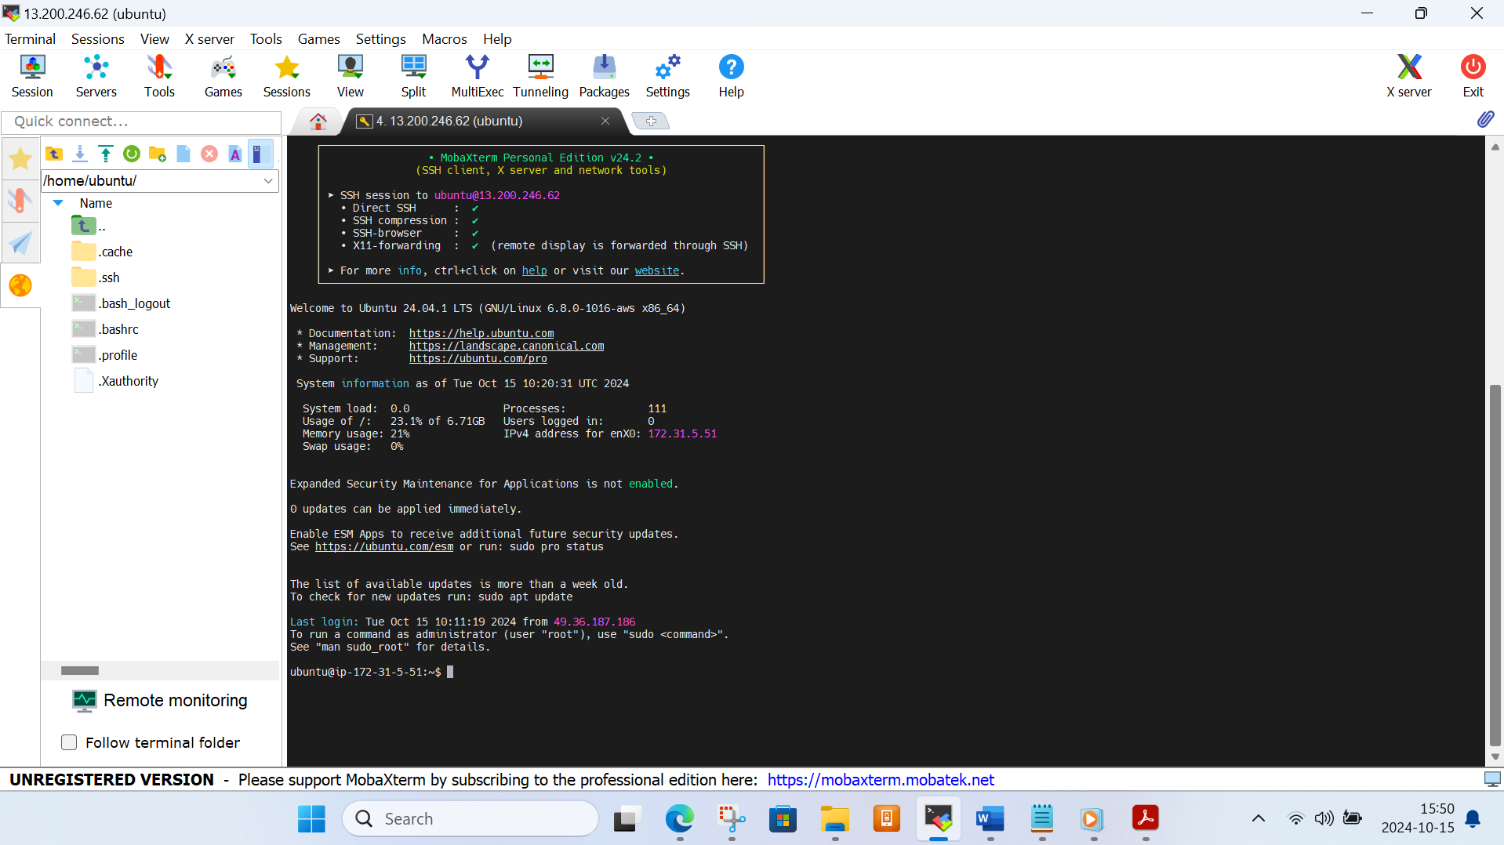

**Create the file and folder**

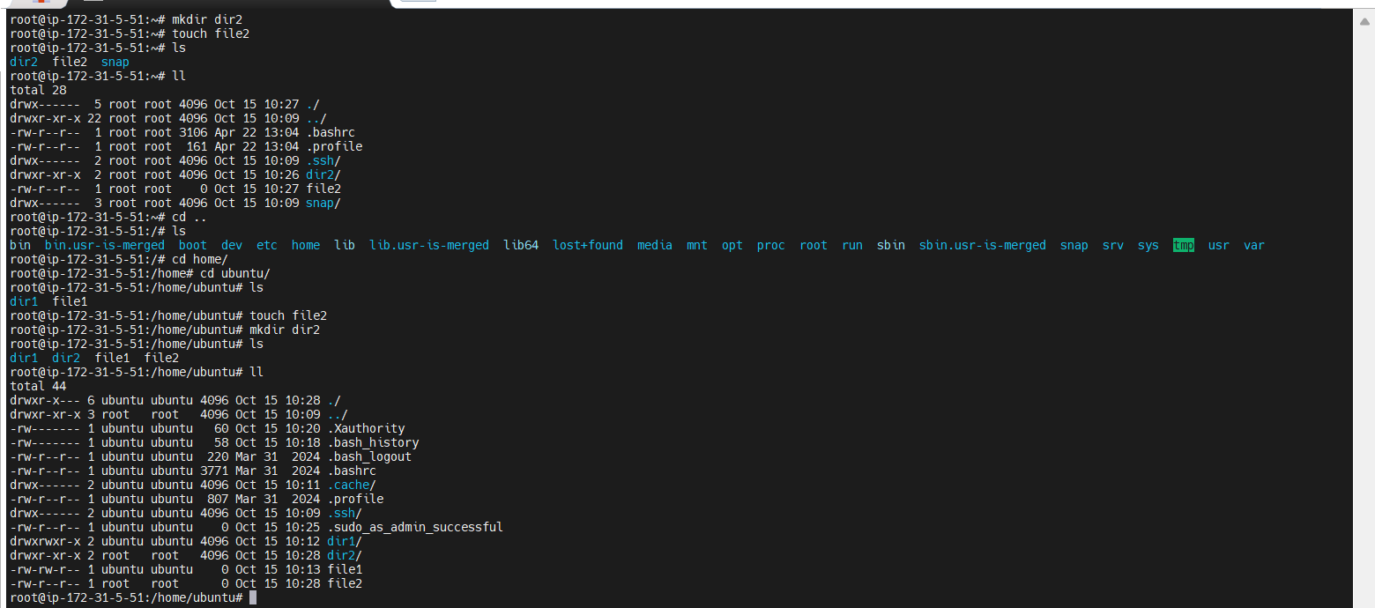

Now change the Ownership of file1 group we use the command

**sudo chown Krishna file2**

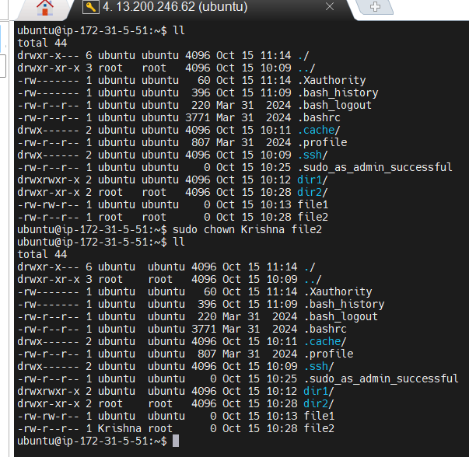

**3. L3 - In EC2 Ubuntu Instance Create Files and Directories and Grand R/W/X Access only to the Owner and User Group.**

**Ans :**

In the same instance we have user below command to create file and folder

**touch file1 file2**

**mkdir ram shyam**

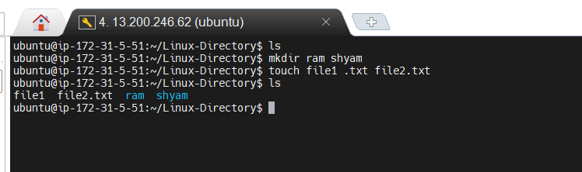

**Read write and execute permission assign to user and group in file1.txt file2.txt and directories**

**chmod 770 file1.txt**

**chmod 770 file2.txt**

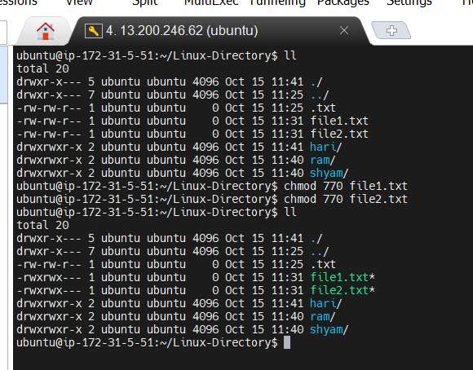

**6. L6 - Write a Linux Shell Script to Install Git, JDK, Maven in EC2 Ubuntu Instance**

**Ans: first of all create the script file.**

**touch script.sh**

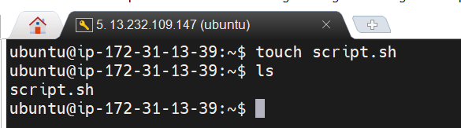

**Change the permission**

**chmod +x script.sh**

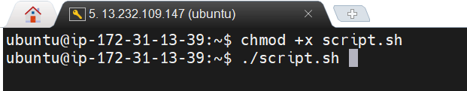

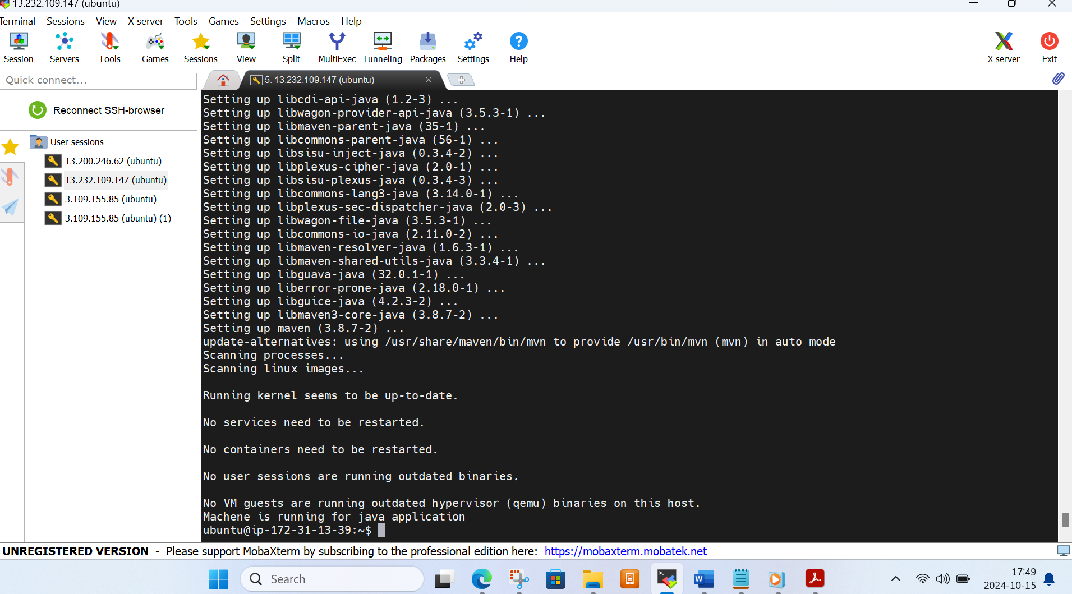

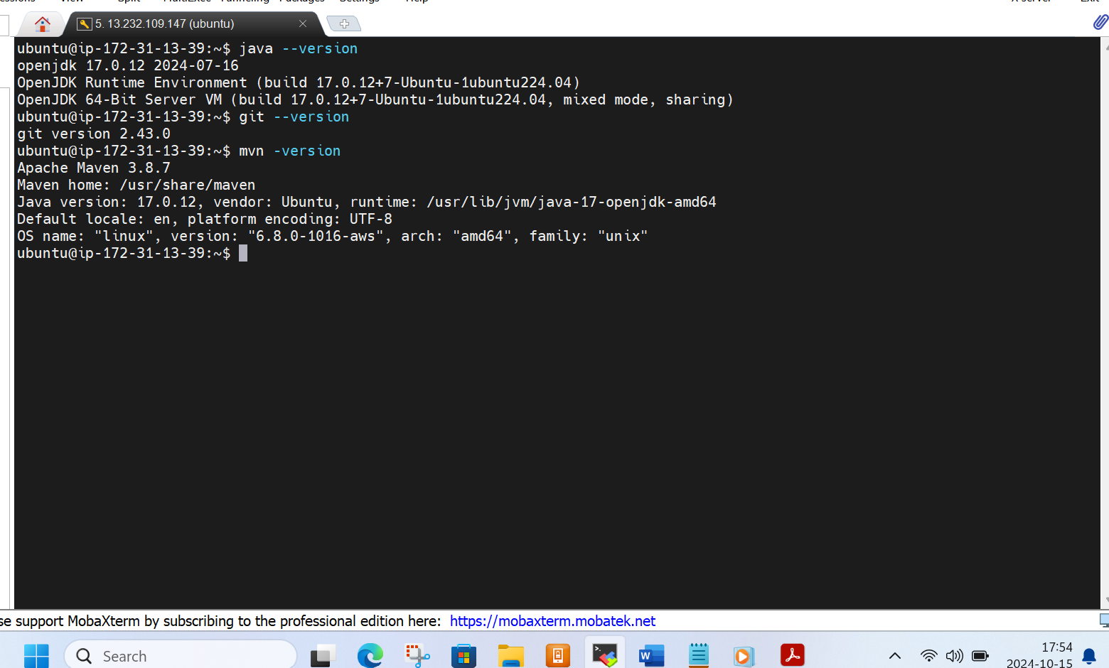

**4. L4 - In EC2 Ubuntu Instance install JDK and setup JAVA_HOME path environment variable**

Ans

**In ans 6 we have installed the JAVA git and Maven**

**Now go to the location**

Cd /usr/lib/jvm/java-17-openjdk-amd64

**Copy the path**

**And edit the environment variable file**

Sudo vi /etc/environment

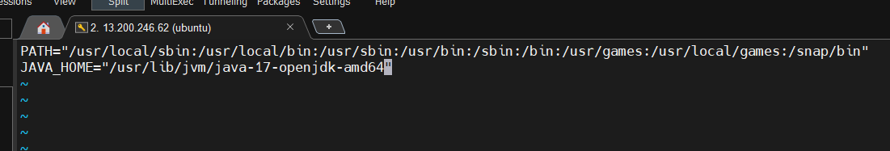

**NOW we have to refresh it by command**

Source /etc/environment

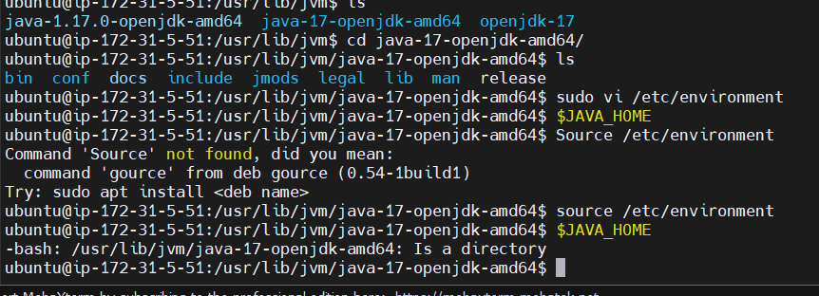

**5. L5 - Create two AWS EC2 Ubuntu Instances to establish SSH Connection and SCP the files from one Instance to another instance.**

**Ans :** first of we created 2 ubuntu instance.

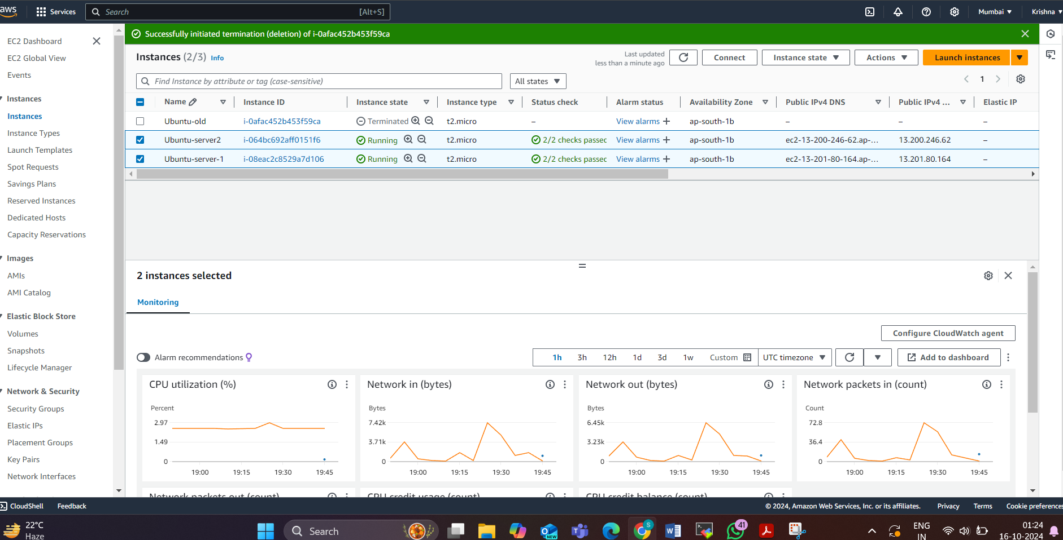

**Now we have to send one filefrom server 1 to server2**

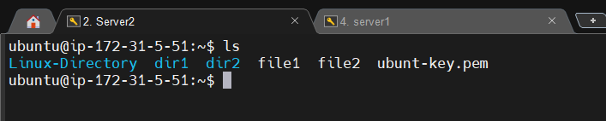

**In server 1 we have to transfer script.sh file to server 2**

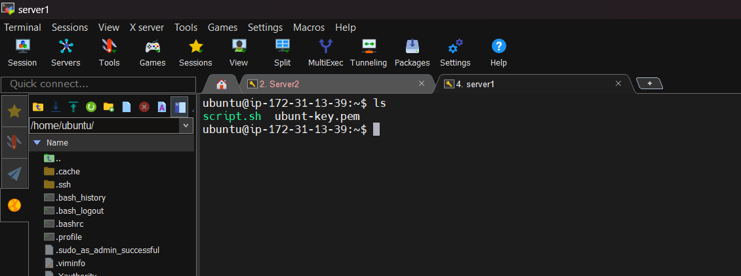

**Change the permission of pem file**

chmod ubuntu-key.pem

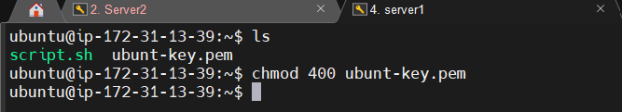

scp -i ubunt-key.pem script.sh ubuntu@13.200.246.62:/home/ubuntu

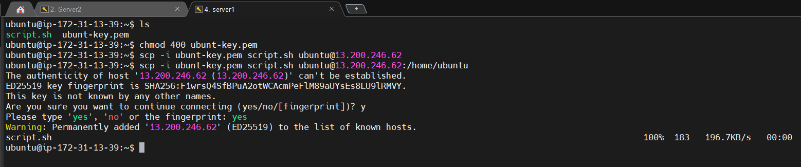

Finally we get Script.sh file in server 1 which is available in server 2

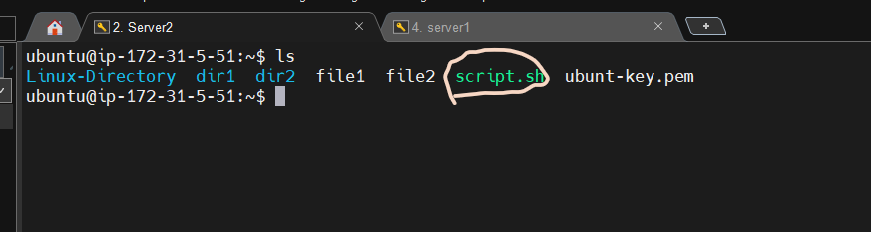

**1. L1 - In EC2 Ubuntu Instance Create a new userand SSH Key pair with an authorized key**

**Ans : create the user ‘ram’ <adduser ram>**

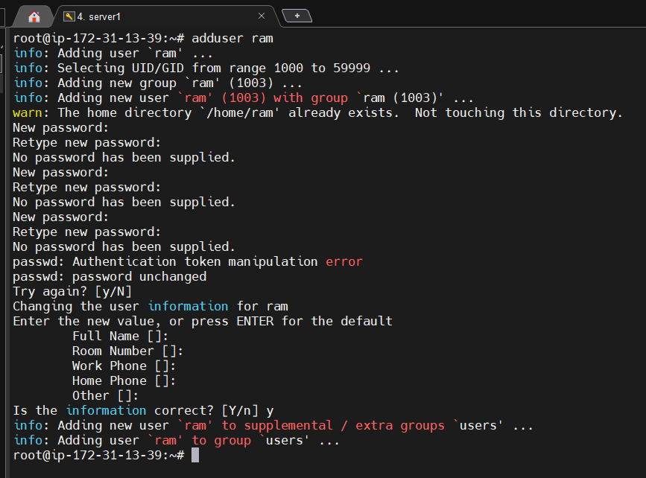

Go to root user by command **<sudo –i>**

And go to location **<cd ~/.ssh>**

And for creation of private and public key we have use below command

**ssh-keygen -t rsa -b 2048 -f ~/.ssh/Anil_key**

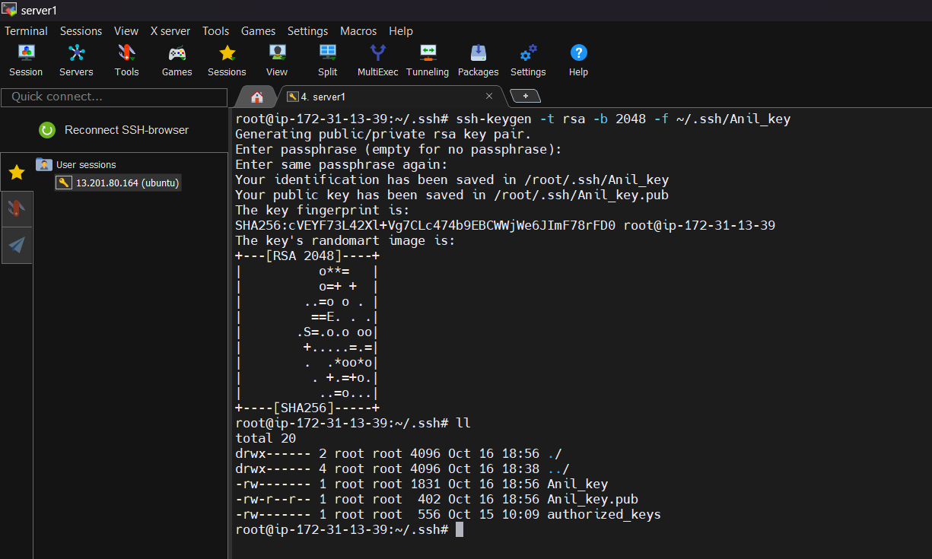

Now Switch to ‘ram’ user by command **<sudo su ram>**

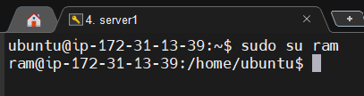

Go to **<cd ~/>** and make .ssh folder

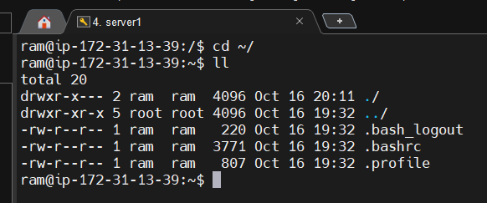

We can not find .ssh folder so we have to create .ssh folder here.

**<mkdir –p ~/.ssh>** or **<mkdir .ssh>**

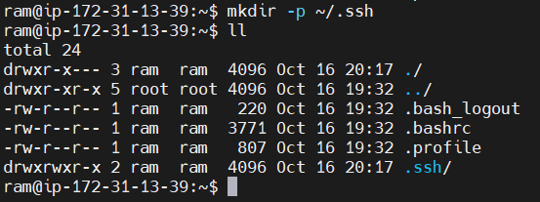

Now go yo .ssh folder **<cd .ssh>**

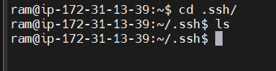

Now create authorized key file by **<vi authorized_keys>** and paste the content of public key of **Anil_key.pub** in the **file** of **authorized_keys**.





Now give the permission read and write of this authorized key

**<chmod 600 authorized_keys>**

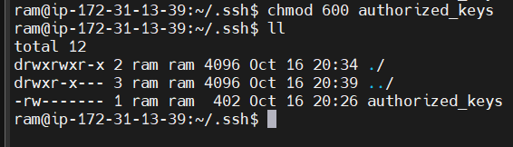

Now we can connect through ram by command

**<ssh -i Anil_key ram@13.201.80.164>**

